**Practical No.5**

Poisson Distribution

Name: Neeraj Sanjay Shah

Roll: 51

Class: F.Y. Data Science

Sub: Probability & Distribution

Sign:

**AIM: To compute Poisson distribution of random variable.**

Q.1 A hardware store sells 3 hammers per day on average. What is the probability that they will sell 5 hammers on a given day?

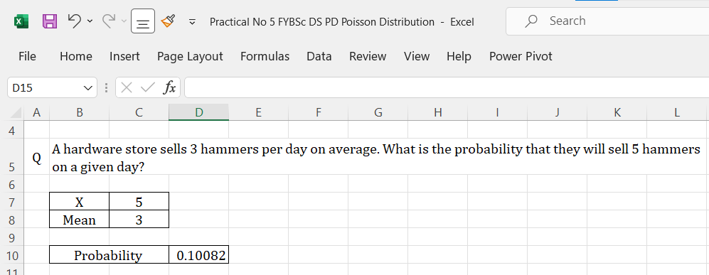

Q.2 A certain store sells 15 cans of tuna per day on average. What is the probability that this store sells more than 20 cans of tuna in a given day?

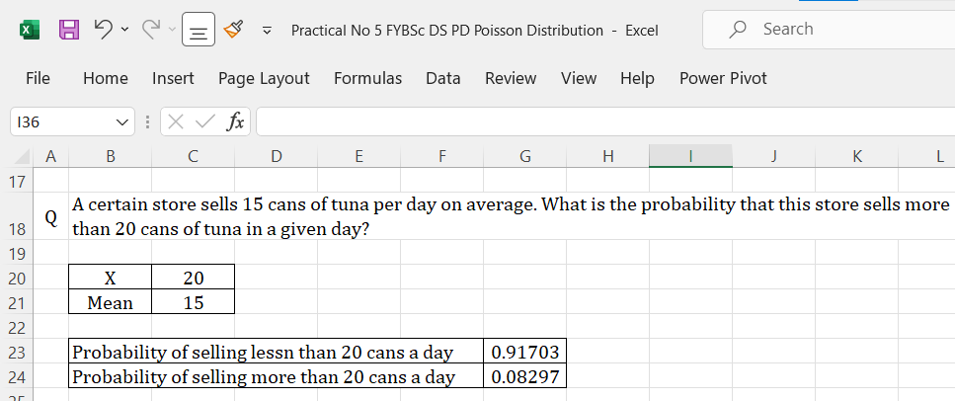

Q.3 A certain sporting goods store sells seven basketballs per day on average. What is the probability that this store sells four or less basketballs in a given day?

